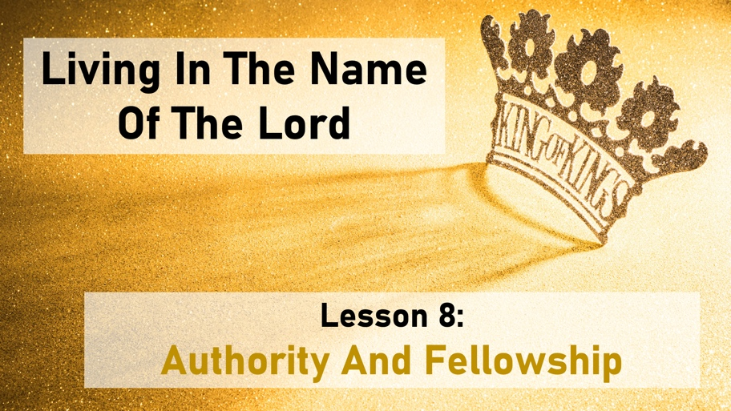

While we have been focused on how Jesus’s authority applies to know how we can obey God, Jesus’s authority also has implications for how we interact with others. “Fellowship” refers to jointly participating in something. However, while we might jointly participate with people in many things (i.e. a meal, an activity, a job, etc.), Biblical fellowship is something much more special. For, Biblical fellowship is all about sharing in a relationship with God through Jesus Christ and all that relationship entails. And, although Jesus wants His followers to be united (John 17:20-23; 1 Corinthians 1:10; Ephesians 4:1-6), following Jesus’s authority also recognizes that fellowship will require division (since Jesus is not in fellowship with all people).

The purpose of this lesson is to learn how to use Jesus’s authority to make fellowship decisions regarding individual and congregational fellowship.

**Fellowship And Sin**

**Christian fellowship is based on a relationship with God.** Jesus’s sacrifice and the gospel’s message is meant to bring people into a right relationship with God (2 Corinthians 5:18-19). So, Christians are called into fellowship with God’s Son, Jesus Christ, through the gospel (1 Corinthians 1:9; 2 Thessalonians 2:14). Whenever someone obeys the gospel to become a Christian, he/she is brought into the number of those who are in fellowship with God and being saved (Acts 2:41-47). Then, entering this fellowship also brings the Christian into fellowship with others who are in a right relationship with God. Christian fellowship, then, involves sharing in a mutual faith and hope (Titus 1:4; 2 Peter 1:1; Jude 1:3). Then, note that while all Christians are in fellowship as God’s children, Christians are taught to join themselves to other Christians in a special way in their local community (called a local church).

**Sin breaks fellowship with God.** Remember that sin involves rebellion against Jesus’s authority (doing what Jesus says not to do or not doing what Jesus says to do). Sin is a big deal because it separates people from God (Romans 6:23; 1 John 1:5-6). So, fellowship with God is a conditional thing – since a holy God cannot remain in fellowship with one who is in darkness (sin). Having this fellowship with God broken results in us being in a lost condition and being separated from every spiritual blessing God has provided through Jesus.

**Sin breaks fellowship with other Christians.** Since spiritual fellowship between Christians exists because of a shared relationship with God, it is then dependent on that mutual relationship with God continuing (1 John 1:7). Although the principles involved in fellowship are not complicated, fellowship questions are not always easily answered. But, we must make judgments about fellowship as best we can – on both the individual and congregational levels. Note that there is no authority from Jesus to make fellowship decisions on any larger level than these (i.e. no brotherhood-wide fellowship decisions all Christians and churches must be forced to abide by).

First, individual Christians must make fellowship decisions (Matthew 7:15-20; 2 John 1:9-11). These involve decisions like: Who you will consider yourself to be in fellowship with, what church you will fellowship with, who you will partner with in your work for the Lord, etc. Second, local churches must make fellowship decisions (Acts 20:28-31; 2 Thessalonians 3:6, 14-15). These involve decisions like: Who will be welcomed as a member of the church, who must be disfellowshipped, who the church can financially help, who the church can partner with in sharing the gospel, etc.

**Two dangers regarding fellowship.** As Christians and local churches try to live according to Jesus’s authority and make the proper judgments about fellowship, two dangers must be avoided. Danger #1 is excluding from fellowship one who is in fellowship with God, since no one has the authority to withhold fellowship from someone God has welcomed into fellowship. An example of doing this can be seen in 3 John 1:9-10. Danger #2 is extending fellowship to one who is not in fellowship with God, since no one has the authority to extend fellowship to someone God has not extended fellowship to. An example of doing this can be seen in 1 Corinthians 5:1-2. To avoid these dangers, use God’s criteria for fellowship by evaluating if someone is presently in fellowship with God (1 John 1:5-7; Acts 9:26-28; Ephesians 5:11; 1 Corinthians 1:9). If so, accept them into fellowship. If not, do not accept them into fellowship.

**Unity must not be pursued at the expense of truth.** Many promote a “unity in diversity” claim, saying that we can be in fellowship even though we do not agree about what Jesus teaches or how to obey Him – just as long as we all believe in Jesus. But, although Jesus wants unity in the truth He has revealed through the Spirit (Ephesians 4:1-6), Jesus also said He came to bring division (Matthew 10:34-39). This division happens whenever some people believe and obey Jesus, while others do not. In fact, Jesus even shows us that some divisions work to necessarily distinguish between those who are truly living in submission to Him and those who are not (1 Corinthians 11:19). So, we must not compromise Jesus’s authority in the name of “unity.” Rather, we must be devoted to King Jesus (Matthew 12:30)!

**Principles For Making Fellowship Decisions**

**Situations where Jesus’s authority is rejected.** Since God does not extend His fellowship to those who reject Jesus’s authority, Christians must not do so either. Consider a few examples when this is the case and observe what must be done in the associated passages. First, false teachers reject Jesus’s authority and must be avoided so others are not misled (2 Peter 2:1-3; Romans 16:17-18). Second, sinners who will not repent have never entered a right relationship with God and should be viewed as being spiritually lost (Romans 10:1-3). Third, erring Christians who will not repent must no longer be viewed as being in a right relationship with God (Matthew 18:15-17; 1 Corinthians 5:9-13; 2 Thessalonians 3:6, 14-15).

**Situations that call for patience.** Both people and local churches are undoubtedly imperfect. If there was no room for patience, then, no Christian would ever be in fellowship with anyone else – and no local church would ever exist! Consider a few examples in which we can see Jesus’s approval of patience in the area of fellowship. First, those who are ignorant of their error should have the truth explained to them so they can change the error (Acts 18:24-28). Second, Christians should patiently restore the erring so they turn back to God (Galatians 6:1; James 5:19-20; Matthew 18:15-17). Third, people must be given the opportunity to make progress in making changes and following the Lord (consider the 1 Corinthians letter and all the corrections that needed to be made).

**Situations that cause one to participate in sin.** There is a big difference between patience and toleration! Careful evaluation must be made by both individual Christians and local churches as to whether they are being patient to give opportunity for repentance or tolerating sin with no real intention of the sin being corrected. Consider a few examples in which we can see Jesus’s disapproval of tolerating and participating in sin. First, welcoming a false teacher with no serious efforts to correct such a one makes one guilty of participating in their evil works (2 John 1:9-11; Revelation 2:14-16). Second, participating in something that does not have Jesus’s approval is strictly forbidden (Ephesians 5:6-11). Third, overlooking someone who will not repent of the sin he/she is engaged in makes one guilty before God (1 Corinthians 5; Revelation 2:20-23)

**Situations involving liberties.** Jesus also addresses areas in which two (or more) different things are authorized and warns about making fellowship decisions He does not approve. Romans 14 deals with such matters (i.e. the eating of meat; as well as 1 Corinthians 8-10). In these matters, Romans 14 labels those who have the accurate knowledge (i.e. permission to eat meat) as the “strong” and those who are conscientiously opposed to the thing (i.e. believes he/she should eat only vegetables) as the “weak.” God says the “strong” must welcome the one who is “weak” and must not argue about the disputed matters (14:1); and must not cause such a one to stumble so as to violate his/her conscience and sin (14:13-14). Then, God says the “weak” must not judge/condemn the “strong” for exercising his/her liberties (14:3). Regarding fellowship, Jesus teaches those who disagree over these matters of liberty are both acceptable to Him – and must accept each other and find ways to work together in the Lord’s kingdom (15:7)!

**Conclusion**

Living in the name of the Lord requires Jesus’s disciples to make decisions about fellowship with others. Failing to make the proper judgments about fellowship has catastrophic consequences. For example, those unjustly excluded from fellowship can be greatly discouraged. And, extending fellowship to those who are not in fellowship with God can result in you losing your salvation. Simply put: Both individual Christians and local churches must constantly remember the need to live in the name of the Lord Jesus Christ in everything (Colossians 3:17). This is the only way we can confidently know we are pleasing to the King!

**Discovering God’s Word Bible Study Series**

Written by Eric Krieg

Watch video @ WWW.GODSAIDSO.COM/DGW497